|  |  |
| --- | --- |
| *Name* | *Toys* |
| *Color* | ***Red*** |
| *Size* | ***2x2*** |
| *Brand* | ***Play Mobil*** |
| *Price* | ***PKR 300*** |



|  |  |
| --- | --- |
| *Name* | *Toys* |
| *Color* | ***Pink*** |
| *Size* | ***2x2*** |
| *Brand* | ***Play Mobil*** |
| *Price* | ***PKR 350*** |

|  |  |
| --- | --- |
| *Name* | *Toys* |
| *Color* | ***White*** |
| *Size* | ***2x2*** |
| *Brand* | ***Play Mobil*** |
| *Price* | ***PKR 350*** |



|  |  |
| --- | --- |
| *Name* | *Toys* |
| *Color* | ***Yellow*** |
| *Size* | ***2x2*** |
| *Brand* | ***Play Mobil*** |
| *Price* | ***PKR 350*** |

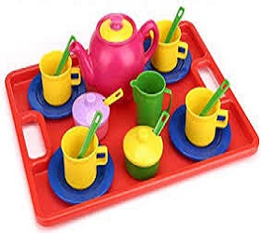

|  |  |
| --- | --- |
| *Name* | *Toys* |
| *Color* | ***Red*** |
| *Size* | ***2x2*** |
| *Brand* | ***Play Mobil*** |
| *Price* | ***PKR 3500*** |

|  |  |
| --- | --- |
| *Name* | *Toys* |
| *Color* | ***Grey*** |
| *Size* | ***2x2*** |
| *Brand* | ***Play Mobil*** |
| *Price* | ***PKR 350*** |

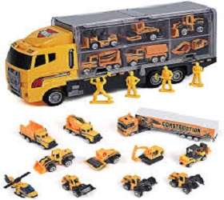

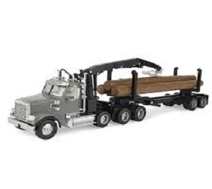

|  |  |
| --- | --- |
| *Name* | *Toys* |
| *Color* | ***Blue*** |
| *Size* | ***2x2*** |
| *Brand* | ***Play Mobil*** |
| *Price* | ***PKR 350*** |

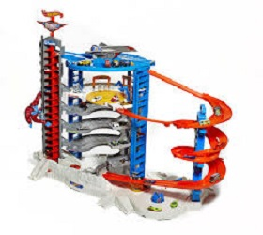

|  |  |
| --- | --- |
| *Name* | *Toys* |
| *Color* | ***Red*** |
| *Size* | ***2x2*** |
| *Brand* | ***Play Mobil*** |
| *Price* | ***PKR 350*** |

|  |  |
| --- | --- |
| *Name* | *Toys* |
| *Color* | ***White*** |
| *Size* | ***2x2*** |
| *Brand* | ***Play Mobil*** |
| *Price* | ***PKR 350*** |

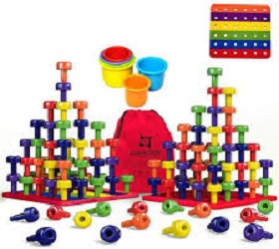





|  |  |
| --- | --- |
| *Name* | *Toys* |
| *Color* | ***White*** |
| *Size* | ***2x2*** |
| *Brand* | ***Play Mobil*** |
| *Price* | ***PKR 350*** |

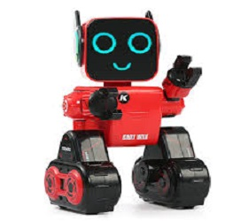

|  |  |
| --- | --- |
| *Name* | *Toys* |
| *Color* | ***Red*** |
| *Size* | ***2x2*** |
| *Brand* | ***Play Mobil*** |
| *Price* | ***PKR 350*** |



|  |  |
| --- | --- |
| *Name* | *Toys* |
| *Color* | ***Red*** |
| *Size* | ***2x2*** |
| *Brand* | ***Play Mobil*** |
| *Price* | ***PKR 350*** |